AGREEMENT OF PURCHASE AND SALE

___________________________________ (“Purchaser”) agrees to purchase and Hamilton Region Conservation Authority (“Vendor”) agrees to sell the following property (“real property”) in the City of Hamilton described as:

Part of PIN 16934-0371 (LT): PT LT 1, CON 7 BARTON, PART 1 ON 62R-21865; HAMILTON, CITY OF HAMILTON.

Comprising approximately 2.34 acres as illustrated on the attached “Figure 1” on the following terms and conditions:

The purchase price shall be ______________________________________ ($____________) payable as follows:

- a deposit of 10% of the purchase price payable by cheque to the Vendor’s solicitor in Trust (“Deposit Holder”) within twenty-one days of the execution of this Agreement by the Vendor,

- the balance of the purchase price payable on closing (on a Closing Date to be determined pending Provincial Approval as provided for in Section 16 below) to the Vendor by wire transfer subject to the usual adjustments, if applicable

The parties to this Agreement hereby acknowledge that, unless otherwise provided for in this Agreement, the Deposit Holder shall place the deposit in trust in the Deposit Holder’s non-interest bearing Real Estate Trust Account and no interest shall be earned, received or paid on the deposit. If the closing does not occur for any reason other than a breach by the Purchaser of its representations, warranties or covenants under this Agreement or if this Agreement is terminated in accordance with its terms, except where otherwise noted the deposit will remain the property of the Purchaser and the Vendor’s solicitor shall return the full amount of the deposit to the Purchaser. If the closing does not occur because the Purchaser breached any of its representations, warranties or covenants under this Agreement, the full amount of the Deposit together with all accrued interest will become the property of the Vendor.

- The Purchaser is liable for and shall pay all land transfer tax, Sales Taxes, other similar taxes, duties and fees in respect of the registration of the transfer, and other like charges properly payable upon and in connection with the sale and transfer of the real property from the Vendor to the Purchaser. The Purchaser agrees to self-assess, be liable for and remit to the appropriate governmental entity all Sales Taxes payable in connection with its purchase of the real property. The provisions of this Section 2 will not merge n closing and will survive closing or the termination of this Agreement.

- If the Purchaser makes a delivery of an HST certificate, warranty, and indemnity, in a form acceptable to the Vendor, then the Purchaser will not be required to pay to the Vendor, and the Vendor will not be required to collect from the Purchaser, goods and services tax or harmonized sales tax, as applicable (“Sales Taxes”). If the Purchaser does not deliver the HST certificate, warranty, and indemnity, the Purchaser shall pay to the Vendor an amount equal to the Sales Taxes payable on the purchase price on closing in the same manner as the purchase price. The provisions of this Section 3 will not merge on closing and will survive closing or the termination of this Agreement.

- Vacant possession shall be given to the Purchaser on closing.

- The Purchaser shall have until fifteen (15) days prior to closing to investigate the title to the real property and to investigate if there is any breach of municipal or other governmental requirements affecting the real property, and if within such time the Purchaser furnishes the Vendor in writing with any valid objection to title or any breach of municipal or other governmental requirement which the Vendor is unable or unwilling to remove, remedy or satisfy and which the Purchaser will not waive, this Agreement, notwithstanding any intermediate acts or negotiations, shall be null and void and the deposits shall be paid to the Purchaser. Notwithstanding the foregoing, the Purchaser acknowledges and agrees that title to the real property will be subject to the Permitted Encumbrances in Schedule A, and the Purchaser agrees to accept title to the Real Property subject to the Permitted Encumbrances.

- The Vendor shall deliver to the Purchaser on the acceptance of this Agreement any survey in the Vendor’s possession and all title deeds and abstracts or copies thereof in the Vendor’s possession, all of which shall be returned to the Vendor if the sale does not close.

- The transfer/deed shall be prepared at the Purchaser’s expense in a form acceptable to both parties. It shall contain the statement of the Vendor and the Vendor’s Solicitor under Section 50(22) of the Planning Act, R.S.O. 1990 c.P.13, and a registerable description of the property.

- The Vendor shall produce evidence on or before closing that the Vendor is not now and on closing will not be a non-resident of Canada under Section 116 of the Income Tax Act.

- The real property is being purchased by the Purchaser on an “as is, where is” basis at the Purchaser’s entire risk and peril, without any express or implied agreement, promise, warranty, guarantee, condition, representation or warranty of any kind whatsoever, or any liability or obligation of the Vendor as to the condition or any other matter relating to the real property, including as to title, value, state of repair, environmental condition, zoning, permits, governmental compliance, threatened claims or litigation, or in respect of any other matter or thing whatsoever and the Vendor specifically negates and disclaims same. The Vendor will have no obligations or responsibility to the Purchaser after closing with respect to any matter relating to the real property or the condition thereof. The provisions of this Section 9 will not merge on closing and will survive closing or the termination of this Agreement.

- The Vendor makes no representation or warranty, express or implied, as to the accuracy or completeness of any information contained in any materials which were produced by the Vendor to the Purchaser. In entering into this Agreement, the Purchaser has relied and will continue to rely upon its own inspections and investigations with respect to the real property, including without limitation, the physical and environmental condition of the real property and a review of any documentation respecting the real property, and the Purchaser acknowledges it is not relying on any information furnished by the Vendor or any other person on behalf of, or at the direction of, the Vendor in connection therewith. The provisions of this Section 10 will not merge on closing and will survive closing or the termination of this Agreement.

- Any tender of documents or money may be made upon the parties or the Solicitor acting for the party on whom tender is desired and it is required that all payments must be made by wire transfer.

- Time shall be of the essence hereof. This Agreement shall enure to the benefit of and be binding upon the parties hereto, their executors, administrators, successors and assigns. This Agreement shall be read with all changes of gender or number required by the context.

- Acceptance of this Agreement or any counter-agreement may be made by either party by email, fax or similar system reproducing the original with the necessary signatures. Such acceptance shall be deemed to be made when the email or fax is received by the party or his or her agent or Solicitor.

- This Agreement is irrevocable by the Purchaser until 4:30 p.m. on the 3rd day of June, 2022 after which time, if not accepted, this Agreement shall be null and void and the deposit shall be returned to the Purchaser.

- In the event of and upon the acceptance of this Agreement by the Vendor, the Vendor has until June 3, 2022 to achieve ratification of the purchase and sale by the Hamilton Conservation Authority Board of Directors. If ratification is not obtained, this Agreement shall be null and void and the deposit shall be returned to the Purchaser.

- The final approval of the sale of the real property is subject to Provincial approval (“Provincial Approval”) and the Agreement must be submitted as part of the approval request to the Minister. As such, the final closing date for this sale will be thirty (30) days following receipt by the Vendor of the Provincial Approval (the “Closing Date”) and the Vendor will confirm the Closing Date with the Purchaser once Provincial Approval is obtained. If Provincial Approval is not obtained on or before February 24, 2023, this Agreement shall be null and void and the deposit shall be returned to the Purchaser.

[Signature Page Follows]

DATED at _ ___ this __ _______ day of __ ________, 2022.

SIGNED, SEALED AND DELIVERED
in the presence of:

____________________________ ______________________________
Witness

The Vendor hereby accepts this agreement on this _ ____ day of ___ _________ 2022.

HAMILTON REGION CONSERVATION AUTHORITY

Per: ______________________________
Lisa Burnside, Chief Administrative Officer

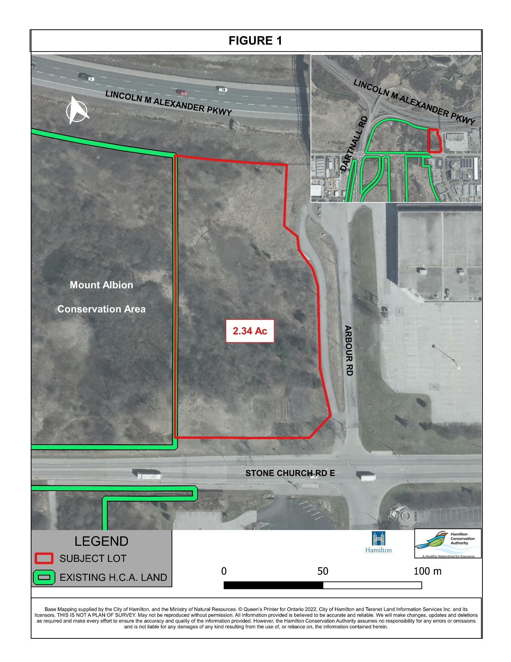
SCHEDULE A
PERMITTED ENCUMBRANCES

- Encumbrances for realty taxes, utilities and other governmental charges and levies that, in each case, are not yet due and are not in arrears;
- inchoate or statutory encumbrances in respect of construction, renovations or current operations, in respect of which the Vendor has, where applicable, complied with the holdback or other similar provisions or requirements of the relevant construction contracts and of the Construction Act (Ontario) and (i) for which no claim has been registered against the land and of which no notice in writing has been given to the Vendor pursuant to the Construction Act (Ontario) or otherwise, or (ii) that relate to obligations not yet due;
- minor title defects or irregularities;
- the reservations, limitations, provisos, conditions, restrictions and exceptions in the letters patent or grant, as the case may be, from the Crown and statutory exceptions and reservations to title;
- any easements for drainage, storm or sanitary sewers, public utility lines, or easements for the supply of utilities or services to the lands or adjacent properties, including, without limitation, electricity, water, sewage, gas, telephone, cable television, or telecommunication service;
- any unregistered easement, right of way, or other unregistered interest or claim not disclosed by registered title in respect of the provision of utilities or services to the land or adjacent properties;
- all orders and rights of expropriation of any federal, provincial or municipal authority or agency;
- any defects, irregularities, easements or encroachments that might be revealed by an up-to-date survey;
- The provisions of applicable laws, including by-laws, regulations, airport zoning regulations, ordinates and similar instruments relating to development and zoning;
- Any registered restrictions or covenants that run with the land providing that such are complied with;
- any registered municipal agreements and registered agreements with publicly regulated utilities, providing such have been complied with or security has been posted to ensure compliance and completion; and
- facility cost sharing, servicing, parking, reciprocal and other similar agreements with neighbouring landowners and/or governmental authorities, provided such agreements have been complied with.

